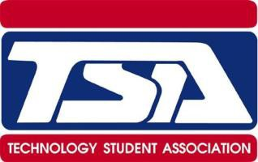**TSA STUDENT AND PARENT INFORMATION SHEET**

Dear Students and Parents,

The Technology Student Association (TSA) is a semester class AND club this year. The class is only open for rising 7th and 8th graders. Students are required to work hard and challenge themselves in many different competition categories. According to the TSA national website, “The Technology Student Association (TSA) is a national, non-profit career and technical student organization (CTSO) of middle and high school students who are engaged in science, technology, engineering, and mathematics (STEM). Since TSA was chartered in 1978, almost 4,000,000 student members have participated through competitions, intracurricular activities, leadership opportunities, community service, and more.”

**Students interested in joining TSA, must meet these requirements:**

* $30 club fee (includes state, national affiliation dues and club t-shirt)
* Excellent behavior during club meetings.
* Excellent work ethic.
* Dedication to putting in the time during meetings to complete competitions.

**TSA events:**

* Officer elections: October 2022
* Club fee due: November 2022
* Parent Meeting: December 2022
* County Competition: March 2023
* State Competition: April 2023
* Fundraising throughout the year to assist with travel and entry expenses for student projects

SFMS TSA website: <https://www.bcbe.org/domain/3652>

Alabama TSA website: <https://alabamatsa.rocks/>

National TSA website: <http://tsaweb.org/>

TSA students are required to attend the county and state competition. Students are required to participate in a minimum of one event and a maximum of four events. If you have any questions or comments about TSA participation, please contact Mrs. Samry at [asamry@bcbe.org](mailto:asamry@bcbe.org).